**Computer Network Work Book**

**Experiment: 2: Execute the following networking commands like ipconfig, tracert, telnet, netsh, ping, nslookup and netstat in the command prompt with a simple topology.**

Step-by-step guide to opening Cisco Packet Tracer and executing the commands in a simple topology:

**Step 1: Launch Cisco Packet Tracer:**

* Double-click the Cisco Packet Tracer icon on your desktop or find it in your applications list to open the program.

**Step 2: Create a Simple Network Topology**

1. **Add Devices:**
   * **Routers and Switches:** Drag and drop a router and a switch from the device list onto the workspace.
   * **PCs:** Drag and drop two PCs onto the workspace. 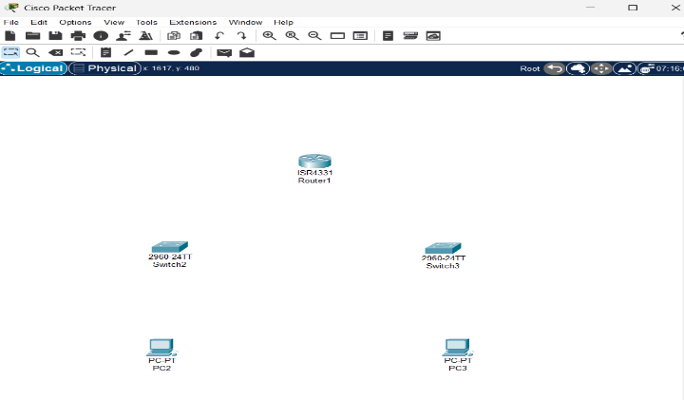
2. **Connect Devices:**
   * Use the **Connection tool** to connect the devices:
     + Connect one PC to the switch using a copper straight-through cable.
     + Connect the switch to the router using another copper straight-through cable.
     + Connect the second PC to the switch using a copper straight-through cable. 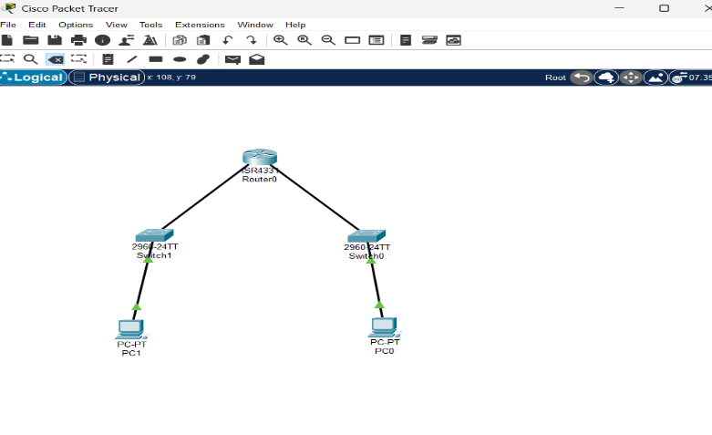

**Step 3: Configure Devices**

1. **Configure the Router:**
   * Click on the router.
   * Go to the Config tab.
   * Assign IP addresses to the router interfaces. 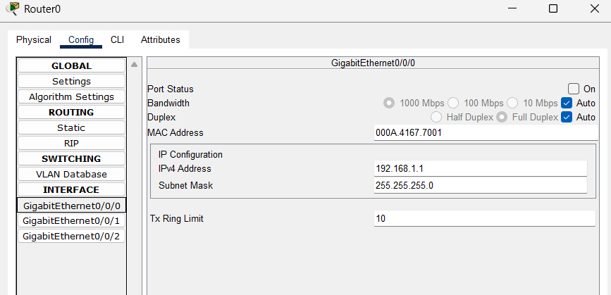
   * **Example:**
     + Interface G0/0: IP address 192.168.1.1, Subnet Mask 255.255.255.0
     + Interface G0/1: IP address 192.168.2.1, Subnet Mask 255.255.255.0
2. **Configure the PCs:**
   * Click on each PC.
   * Go to the Desktop tab and then **IP Configuration**.
   * Assign IP addresses to each PC.

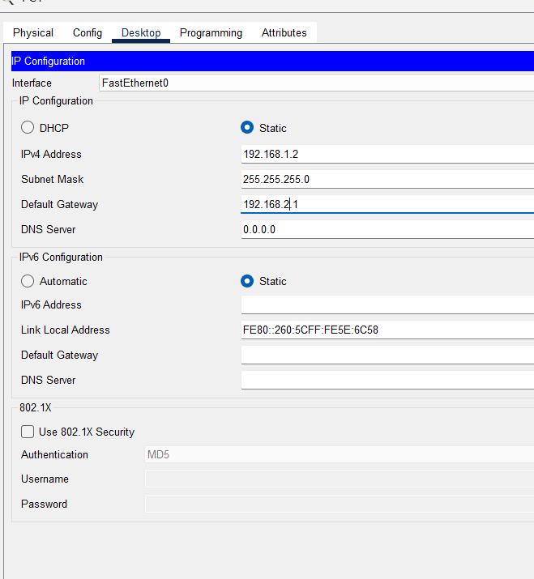

* + **Example:**
    - PC0: IP address 192.168.1.2, Subnet Mask 255.255.255.0, Default Gateway 192.168.1.1
    - PC1: IP address 192.168.2.2, Subnet Mask 255.255.255.0, Default Gateway 192.168.2.1

**Step 4: Execute Networking Commands**

* Click on a PCO.
* Go to the **Desktop** tab and open the **Command Prompt**.

**1. ipconfig:**

This command displays all current TCP/IP network configuration values and refreshes DHCP and DNS settings.

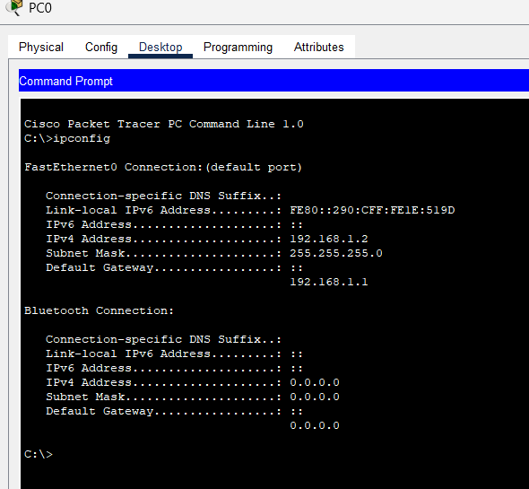

**2. tracert:**

This command traces the path taken to a destination by sending ICMP Echo Request messages.

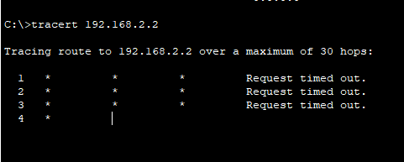

**3. telnet:**

This command is used for interactive communication with another host using the Telnet protocol.  
**Syntax:**

telnet <destination IP> <port>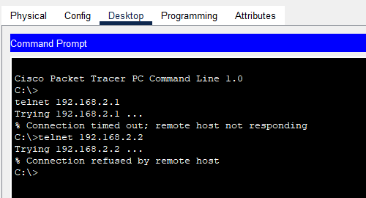

**Configure the Router**

**1. Assign IP Address**

* Click on the router.
* Go to the **Config** tab.
* Select the interface connected to the switch (e.g., **G0/0**).
* Assign: IP Address: 192.168.1.1; Subnet Mask: 255.255.255.0

Router>enable

Router#configure terminal

Router(config)#line vty 0 4

Router(config-line)#password cisco

Router(config-line)#login

Router(config-line)#exit

Router(config)#end

Router#write memory

**1. Open Command Prompt**

* On the **PC0**, go to the **Desktop** tab. Open the **Command Prompt**.

**2. Execute Telnet Command**

telnet <IP> <port>

**Telnet Security:** Telnet is not encrypted and is not secure. For real-world usage, prefer SSH for remote access.

**Enabling Telnet on a Real Router:** If using real equipment, make sure Telnet is enabled and the device is configured to accept Telnet connections.

**4. Router configuration and Brief IP Interface**

This command is a scripting utility that allows you to display or modify the network configuration of a computer.

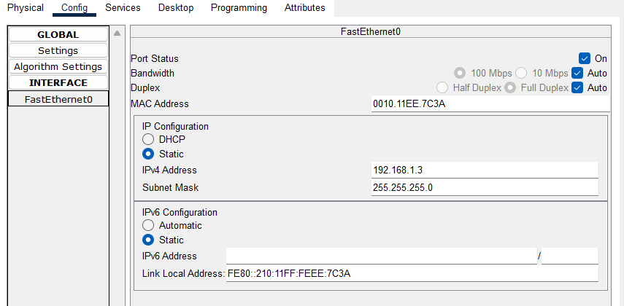

**5. Ping 192.168.2.2**  
**ICMP Echo**

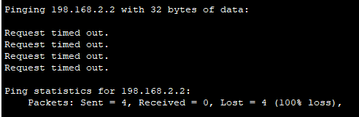

**6. nslookup**  
nslookup www.google.com

This command queries the DNS to obtain domain name or IP address mapping.  
To use the lookup command to resolve a domain name to an IP address in Cisco Packet Tracer, you'll need to ensure that the DNS server is properly configured in your network topology.

**Configure the DNS Server**

1. **Add one server** to act as a DNS server.
2. **Connect both PCs and the server** to the switch using copper straight-through cables.

**Configure the DNS Server**

1. **Assign IP Address**:
   * Click on the server.
   * Go to the **Config** tab and select the **FastEthernet0** interface.
   * Assign the following:
     + IP address: 192.168.1.3
     + Subnet Mask: 255.255.255.0
     + Default Gateway: 192.168.1.1
2. **Configure DNS Service**:
   * Go to the **Services** tab on the server.
   * Select **DNS** and turn the service **On**.
   * Add an entry for www.google.com with an IP address such as 8.8.8.8.

**Use the nslookup Command**

1. **Open Command Prompt on PC0**:
   * Go to the **Desktop** tab on PC0.
   * Open the **Command Prompt**.
2. **Execute the nslookup Command**:
   * Type nslookup www.google.com and press Enter.

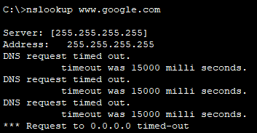

This confirms that the PC successfully queried the DNS server and resolved the domain name www.google.com to the corresponding IP address.

* **DNS Server Configuration:** Ensure that the DNS server is correctly configured and running.  
  **DNS Entries:** The DNS entry for www.google.com should be added to the DNS server with an IP address.
* **Network Configuration:** Ensure that all devices are correctly connected and configured with appropriate IP addresses, subnet masks, and default gateways.

**7. Netstat**  
This command displays network connections for the Transmission Control Protocol (TCP), routing tables, and a number of network interface and network protocol statistics. The netstat command is used to display network connections, routing tables, interface statistics, masquerade connections, and multicast memberships. 